Fiery Trials Intensifying As We Pray Against WW3
December 14, 2016
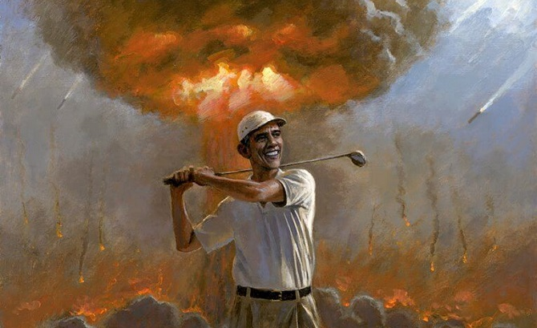
May the sweet presence of Jesus keep your hearts and minds in His Peace.

And first off, I want to thank you all for your prayers. Really, you've been holding me up with your prayers, holding Ezekiel and I up. And all of us on the Heartdweller team. The betrayal that we experienced, unfortunately, reached across passwords, bank accounts and a lot of other things. There's been a complete and total challenge to dig out of. Just when I think I've got it mastered, another log-in doesn't work and I have to get in touch with the people and get a new password, because my account is shut down.

Have you ever had to get in touch with Google over a problem with your account?? lol... oh, boy. THAT was fun...! That was really fun.

And if you see my books on Amazon, books and CD's that they aren't there - it's because some very unkind person shut down my Amazon seller's account.

So...needless to say, there's just been a lot of offerings to make to the Lord. And I may not feel happy and good about the whole thing, but I'm still making the act of the will to thank the Lord for these challenges. And it's interesting, because forgiveness is something that just doesn't happen once - it's like every time I turn around, there's another thing to forgive. And the Lord is really training me in walking on the water and forgiving. And your prayers have made such a difference, and your support. Thank you so much for your donations, they are really needed, and we really appreciate them.

So, right now, we're still digging out of this mess, and that's the reason why I didn't get a message up to you yesterday, because it gets very, very complicated trying to restore accounts. But the Lord is in charge and the Lord has allowed and the Lord is using it and souls are being saved. And the president is going to get into office, the new president. And there's going to be a wonderful move of God in this country. And this is my tiny, little part, all of these endless - seemingly endless inconveniences and snags. That's just my part, and I'm so happy that the Lord has given me something, and that He is keeping me in peace.

So, that's the reason why the message wasn't up yesterday, 'cause I got this message two days ago.

You know, as I look back on this situation and the things that I'm discovering now that have been affected by it, all I can say is that this is a soul that is very tortured and hurting inside. And we need to pray for this soul. I'm not going to give you a name, I'm just saying please. Pray for this soul, because there's so much good there. There's so much care and concern for the poor, and wanting to help other people. There's some real beauty there, some really, really strong beauty.

Once that person comes to know the Lord, they're going to be a wonderful servant for the Kingdom of God. It's just a matter of time, because He has His hand on them and He's not about to abandon. But there's some terribly deep wounds in that soul and let's keep them in our prayers, that the good will come forth from this person and overcome the evil. The battle has been so intense. Just when I think I've got my footing, out comes the rug from underneath me. And today, even Ezekiel was sick. But he got sick with Lying symptoms, and the Lord was asking him to cooperate in giving this suffering. Pains in his body that were totally different than what he'd had before - to cooperate with this, and to offer it to Him because He needed it.

Later, I talked with Dr. Sherry and she said the Lord is calling for a tremendous amount of fasting and prayer, every sacrifice we can possibly give Him. The world situation is right on the brink and very, very dire. She told me the Lord was needing tremendous amounts of graces right now, a tremendous amount. And my theory about that, and I've said all along, was that the president in office right now was going to pull something, like a nuclear war, off - so that there could be martial law and he wouldn't have to leave the White House. I've just felt that, all along, that he was going to try and pull that off.

But the thing is, that button's not going to work, 'cause we're offering sacrifices and praying and interceding, really with all your heart, guys. With all your hearts, please pray that this will not happen. And if you have any inconveniences, rejoice over them, 'cause that's your opportunity to stop this evil scheme from taking place. Just like the missiles turned around in Israel when they were headed for an apartment complex. The missile turned around and went out to sea, and that wasn't the first time it happened. In the same way, the Lord can totally stop that big button from going off. And I have felt that all along, that would be the very tactic the enemy would try to use to prevent Donald Trump from taking office.

So please, pray with all your hearts and all your strength that this will NOT happen, that the Lord will put an end to the plan and totally frustrate them. Recall, too, that last year around Christmastime, that the Queen of England and the Pope both said to "enjoy this Christmas, because it would be our last on this Earth." So that tells you how serious they were about having a war before the next Christmas came.

But you know? Man makes his plans, but God carries through His.

And the Lord began:
"I know how hard this trial has been for you, My Dearest. It has been a complete and perfect sacrifice for your country and the salvation of souls. Nothing has been wasted, Clare. Look at all the inconveniences, all of it has been used by Me to bring My Kingdom to this Earth. Not only that, look at all the followers on your channel who have learned invaluable lessons about living in the midst of turmoil.

"Don’t you see? This has been very much a part of your work. Breakthroughs are coming, this tragedy will not haunt you forever. We will at some point break through all the pain and move on. Until then, carry this cross like a soldier. So much good is to come from this. So much good. You will not see what I accomplished through these sufferings until you are with Me in Heaven.

"But will you please take My word for it; great things are going to emerge out of this tragedy. But remember, the greatest tragedy is the loss of this soul. This soul means a great deal to Me. There is yet a good harvest from this soul, but they must descend much further before they will accept Me. And even then, there are no guarantees. I do plan on keeping them alive for a long time if necessary, to bring them to Myself."

Jesus, please don’t tell me this, it makes me heart sick that this may not end well.

"I tell you, because your suffering is making an impact for the good in their life. I tell you this so you can be comforted, but now you are sharing in My grief about where they are now and where they are going before things turn around.

"In the meantime, you will move forward in your ministry and I have many surprises planned for you."

And I was thinking at that point, 'Really?! Like what?'

And He said, "No, I’m not going to tell you! I like surprises and they wouldn’t be a surprise if I told you!"

Lord, the most painful part of this is that I feel drawn away from You by all these distractions and endless snags. All these things I must do to make my life run smoothly again and for this ministry.

"And yet I am here, holding you, talking to you and with you all the more. It is a suffering for you that your mind so easily wanders back into all these worldly concerns. Can you accept that also as a suffering?"

That’s a really hard one, Lord. It has so many repercussions. not the least of which is the constant feeling of shortchanging You.

"That’s what I mean," He replied. "It is also an exercise in sanctity. From moment to moment, who means more to you? Your own security? Or time with Me? Do you see? This is a fiery trial on many levels."

And here He changed the subject of the message, so we'll continue this tomorrow.

Please remember to pray for the world's condition and to offer any inconveniences you have. Thank you. The Lord bless you all, Heartdwellers. Thank you for being part of our family.

